**YEAR 12 PHYSICS**

**Revision – Particles Waves and Quanta**

**Section 1: Short response (30%) 15 marks**

1. The following passage shows part of a student’s revision notes which contain several errors. Identify three of the errors in the student’s notes and suggest corrections for the errors.



Error

Correction

Error

Correction

Error

Correction

(3 marks)

2. You are in a pet shop when you notice that when a parrot in a nearby cage squawks, a bell in its cage rings. Describe clearly the process that causes the bell to ring.

(3 marks)

Why does the bell ring at a particular frequency?

(1 mark)

3. A travelling wave, moving to the right, is set up on a long string. The wave has a wavelength of 20·0cm, and an amplitude of 5·00 cm. Diagram 1 below shows a section of the string at a particular time, t0, and diagram 2 shows the same section 1.00 s later.

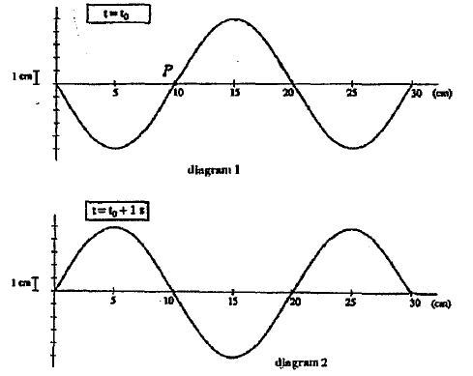

a) What is the lowest frequency that the wave may have?

(2 marks)

b) What is the speed of the wave?

(2 marks)

4. After discharging an arrow at the afternoon archery lesson, a student notices a 'twang' in the string of the bow. It vibrates at its fundamental frequency of about 300 Hz. ESTIMATE the velocity of the wave in the string. (State assumptions and show workings clearly). '

(4 marks)

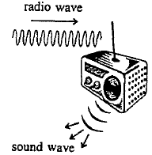**Section 2: Problem Solving (50%) 25 Marks**

1. a) The diagram shows how two different waves are involved when listening to a radio.

The radio wave is an electro-magnetic transverse wave and the sound wave is a mechanical longitudinal wave.

Explain, with reference to these waves, what is meant by the wave properties described in the previous sentence.

(4 marks)

b) The graph, below, shows how the position of the loudspeaker cone changes when it is reproducing a sound of frequency 250 Hz.

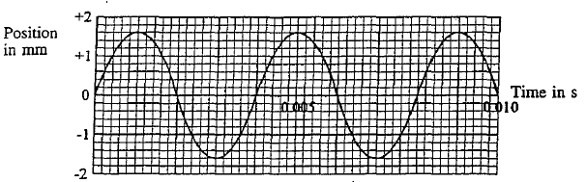

Sketch, on the grid, a graph that shows the loudspeaker cone moving with reduced amplitude and half the frequency.

(2 marks)

2. While on vacation, Brigette visited a European castle. It was a windy day, and she could hear

a sound coming from the fireplace. She concluded that the wind was generating a standing wave of frequency 30.0 Hz in the chimney, which was acting as a pipe **open at both ends**,

(a) Draw labelled sketches of the fundamental and next possible harmonic of the standing wave

that could exist in the chimney.

(2 marks)

(b) Assuming that the sound Brigette heard was due to the fundamental standing wave, calculate the length of the chimney.

(2 marks)

3. a) The diagram to the side shows some of the energy levels for sodium atoms contained in sodium vapour lamps similar to those used at pedestrian crossings.

An electron in the ground state (El) is excited to an upper energy level by receiving energy from a bombarding electron. From this level it undergoes a transition to the level immediately below it and emits a photon of wavelength 2.76 x 10-6 m.

To which upper energy level did the excited electron move when it was struck by the bombarding electron?

(4 marks)

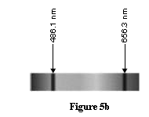b) With a spectroscope, Val examines the spectrum of light from the sun. The spectrum is continuous, with colours ranging from red to violet as shown in Figure 5b.

However there were black lines in the spectrum corresponding to the line emission spectra shown by hydrogen when it is excited.

Explain why these dark lines are present in the spectrum from the sun.

(3 marks)

c)In the spaces below, state the type of spectrum seen from each source.

(i)Incandescent light globe

(ii)Mercury vapour lamp

(2 marks)

d)State the electron mechanism, in each of the sources below, that produces each spectrum.

(i)Incandescent light globe

(ii)Mercury vapour lamp

(2 marks)

4. A Year 12 physics class is studying Einstein’s special relativity. The teacher postulates a thought experiment: Imagine you are travelling at a speed of 2.9 x108 ms-1 alongside a beam of light. What would you measure the speed of a beam of light to be?

Two students put up their hands to offer an answer.

**Hilary says**: You would measure the beam of light to be moving away from you at 3x108 ms-1.

**Ryan says**: You would measure the beam of light to be moving away at at 0.1 ms-1.

Which student’s answer is consistent with Einstein’s special theory of relativity? In the space below, write your choice and explain your reasoning.

(3 marks)

**Section 3: Comprehension (20%) = 10 Marks**

Carefully read and examine the information below and answer all questions clearly and concisely.

Fake waves break the ice in winter Martin Hindley



WINTER ice can severely disrupt shipping around northern coastlines. But now a Canadian marine engineer claims he has found a way of controlling ice formation in ports and harbours. Per Andersen says his wave generator projector could help prevent seawater from freezing over by producing artificial waves.

When seawater is mechanically agitated, the deeper, warmer water mixes with the colder surface water. This process should prevent ice from building up, says Andersen, who has tested the prototype in Canada.

The machine is 7·5 metres long. It consists of a floating helical roller, similar to a large corkscrew, supported at either end by pontoons. The roller is rotated in the water by an electric motor to create a train of waves several hundred millimetres high. According to Andersen, artificial waves have a higher height-to-length ratio than natural waves, making them better able to displace water. As a result more water is drawn up from the warmer depths of the sea. Andersen says that greater mixing occurs at the surface just where the de-icing effect needs to be the greatest. With a conventional propeller-driven de-icing system, mixing is less effective because particle velocities tend towards zero near the surface, he says.

Trials of Andersen's system in Oshawa harbour, Ontario, have produced artificial waves nearly 150 mm high, exceeding Andersen's theoretical projections by half. The wave train measured over 15 metres in width and 100 metres in length, and would certainly have had an effect on ice formation, he says. Andersen also says that it takes very little energy to produce the waves.

In Toronto harbour, a single main access channel makes the ferry berths particularly vulnerable to ice. Ken Lundy, manager of works and chief engineer with the Toronto Harbour Commissioners, says Andersen's wave generator could be used where a build up of ice in the berths tends to damage the quay. “The machine worked well at pushing ice out of the way at Oshawa” he says.

Meanwhile, an environmental group based in Atlanta is building a version of the generator measuring 5 metres long to improve water quality in lakes. They believe that better aeration will reduce problems such as excessive algal bloom, weed growth and eutrophication.

"Most conventional machines, such as bubbler systems and wind-driven turbines, only have an effect on vertical columns of water," says Andersen. His device should work over much wider areas. The mixing

action of the artificial waves extends to a depth of half the wavelength, which is equivalent to around 600 mm for the wave generator projector. So the device should not stir up sediments from the lake bed.

1. The wave diagram (displacement) of particles has all the appearances of a diagrammatic portrayal of a standing (i.e. stationary) wave. Would the production of a standing wave be likely or desirable. (Explain your answers).

(2 marks)

2. The diagram shows water molecules in rotational motion as the wave progresses. Is it the transverse or longitudinal component of this motion that best supports the "design purpose" of this machine?

(1 mark)

3. What surface area of water undergoes the mixing effect in Andersen's Oshawa harbour trials?

(2 marks)

4. Andersen's waves are generated by the rotation of a helical roller.

Use the words **increase, decrease or no change** to describe the impact on frequency, wavelength, and amplitude **on the generated waves** if the changes (separately) indicated below were made to the roller.

|  |  |  |  |
| --- | --- | --- | --- |
| Roller changes | Frequency | Wavelength | Amplitude |
| Roller is rotated faster  (i.e. Greater RPM) |  |  |  |
| Roller diameter is increased |  |  |  |
| Roller length is increased |  |  |  |
| Roller oscillates vertically in phase with its rotation |  |  |  |

(4 marks: *1/2* mark deduction for each error or omission)

5. A roller rotating at 40.0 RPM ( revolutions per minute) was used in the trials that produced the

mixing depth and wavelength information referred to in the last paragraph of the article. Calculate the

wave speed through the water.

**(**1 mark)